Appendix E
Denotational semantics of Sodium
Revision 1.1—26 Apr 2016
Introduction
This document is the formal specification of the semantics of Sodium, an FRP system based on the concepts from Conal Elliott’s paper “Push-Pull FRP.” The code in this document is in Haskell, and a basic understanding of Haskell is required to understand it. Most readers won’t need this information, but people interested in FRP semantics and developers of FRP systems will find it useful. Note that this has nothing to do with the Haskell implementation of Sodium. The executable version of this specification can be found at https://github.com/SodiumFRP/sodium/blob/master/denotational/.
Revision history
- 1.0 9 (19 May 2015)—First version
- 1.1 (24 July 2015)—The times for streams changed to increasing instead of nondecreasing so that multiple events per time are no longer representable
- 1.1 (8 Oct 2015, 26 Apr 2016)—Minor corrections; no semantic change
Data types
Sodium has two data types:
- Stream a—A sequence of events, equivalent to Conal’s Event
- Cell a—A value that changes over time, equivalent to Conal’s Behavior
We replace Conal’s term event occurrence with event.
Primitives
We define a type T representing time that is a total order. For the Split primitive, we need to extend that definition to be hierarchical such that for any time t we can add children numbered with natural numbers that are all greater than t but smaller than any greater sibling of t. In the executable version, we have used the type
type T = [Int]
with comparison defined such that early list elements have precedence over later ones.
Sodium has 16 primitives. Primitives marked with * are non-primitive, because they can be defined in terms of other primitives:
- Never :: Stream a
- MapS :: (a → b) → Stream a → Stream b
- Snapshot* :: (a → b → c) → Stream a → Cell b → Stream c
- Merge :: Stream a → Stream a → (a → a → a) → Stream a
- Filter :: (a → Bool) → Stream a → Stream a
- SwitchS :: Cell (Stream a) → Stream a
- Execute :: Stream (Reactive a) → Stream a
- Updates :: Cell a → Stream a
- Value :: Cell a → T → Stream a
- Split :: Stream [a] → Stream a
- Constant* :: a → Cell a
- Hold :: a → Stream a → T → Cell a
- MapC :: (a → b) → Cell a → Cell b
- Apply :: Cell (a → b) → Cell a → Cell b
- SwitchC :: Cell (Cell a) → T → Cell a
- Sample :: Behavior a → T → a
Reactive is a helper monad that’s equivalent to Reader T. It represents a computation that’s executed at a particular instant in time. Its declaration is as follows:
data Reactive a = Reactive { run :: T → a }
Execute works with this monad. In the Haskell implementation, Reactive is part of the public interface of Sodium used to construct the four primitives that take a T argument representing the time when that primitive was constructed: Value, Hold, SwitchC, and Sample. Most languages don’t support monads, so they instead use a concept of transactions, but the meaning is the same. The output values of those four primitives can never be sampled before the time t they were constructed, for these reasons:
- The public interface only allows Value, Hold, SwitchC, and Sample to be constructed through Reactive.
- The time at which the simulation is sampled is always increasing.
- The public interface only allows Reactive to be resolved once the simulation has reached time t.
- The public interface only allows streams and cells to be sampled at the current simulation time.
We define semantic domains S a and C a for streams and cells:
- type S a = [(T, a)] for increasing T values
- type C a = (a, [(T, a)]) for increasing T values
S a represents a list of time/value pairs describing the events of the stream. C a represents (initial value, steps) for the cell: the initial value pertains to all times before the first step, and the time/value pairs give the discrete steps in the cell’s value.
We define these semantic functions to transform streams and cells to their semantic domains:
occs :: Stream a → S a
steps :: Cell a → C a
C a is different than Conal Elliott’s semantic domain for behavior, which was
type B a = T → a
The reason for this choice is that it makes Updates and Value possible, and it allows the cell variant of switch to take Cell (Cell a) as its argument instead of Cell a → Stream (Cell a), effectively decoupling it from stepper/hold functionality. Something roughly equivalent to Conal’s switcher can be defined as follows, if we posit that [0] is the smallest possible value of T:
switcher :: Cell a → Stream (Cell a) → Cell a
switcher c s = SwitchC (Hold c s [0]) [0]
We can derive Conal’s B a from C a with an at function:
at :: C a → T → a
at (a, sts) t = last (a : map snd (filter (\(tt, a) → tt < t) sts))
Test cases
Now we’ll give the definitions of the semantic functions occs and steps for each primitive, with test cases to show things are working as expected. MkStream is the inverse of occs, constructing a Stream a from an S a. We use it to feed input into our test cases.
Never
Never :: Stream a
A stream that never fires:
occs Never = []
Test cases
See figure E.1.
let s = Never
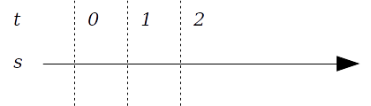
Figure E.1 Never test
MapS
MapS :: (a → b) → Stream a → Stream b
Map a function over a stream:
occs (MapS f s) = map (\(t, a) → (t, f a)) (occs s)
Test cases
See figure E.2.
let s1 = MkStream [([0], 5), ([1], 10), ([2], 12)]
let s2 = MapS (1+) s1
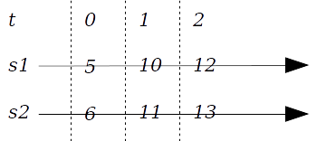
Figure E.2 MapS test
Snapshot
Snapshot :: (a → b → c) → Stream a → Cell b → Stream c
Capture the cell’s observable value as at the time when the stream fires:
occs (Snapshot f s c) = map (\(t, a) → (t, f a (at stsb t))) (occs s)
where stsb = steps c
Note: Snapshot is non-primitive. It can be defined in terms of MapS, Sample, and Execute:
snapshot2 f s c = Execute (MapS (\a → f a <$> sample c) s)
NOTE To make it easier to see the underlying meaning, we’re diagramming cells in their “cooked” form with the observable values it would give us and vertical lines to indicate the steps, not directly in their B a representation of initial value and steps.
Test cases
See figure E.3.
let c = Hold 3 (MkStream [([1], 4), ([5], 7)]) [0]
let s1 = MkStream [([0], 'a'), ([3], 'b'), ([5], 'c')]
let s2 = Snapshot (flip const) s1 c
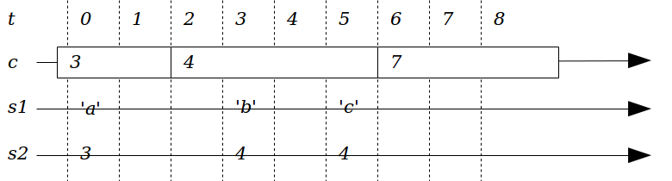
Figure E.3 Snapshot test
Merge
Merge :: Stream a → Stream a → (a → a → a) → Stream a
Merge the events from two streams into one. A stream can have simultaneous events, meaning two or more events with the same value t, which have an order. s3 in the following diagram gives an example. Merge is left-biased, meaning for time t, events originating in the left input event are output before ones from the right:
occs (Merge sa sb) = coalesce f (knit (occs sa) (occs sb))
where knit ((ta, a):as) bs@((tb, _):_) | ta <= tb = (ta, a) : knit as bs
knit as@((ta, _):_) ((tb, b):bs) = (tb, b) : knit as bs
knit as bs = as ++ bs
coalesce :: (a → a → a) → S a → S a
coalesce f ((t1, a1):(t2, a2):as) | t1 == t2 = coalesce f ((t1, f a1 a2):as)
coalesce f (ta:as) = ta : coalesce f as
coalesce f [] = []
Test cases
See figure E.4.
let s1 = MkStream [([0], 0), ([2], 2)]
let s2 = MkStream [([1], 10), ([2], 20), ([3], 30)]
let s3 = Merge s1 s2 (+)
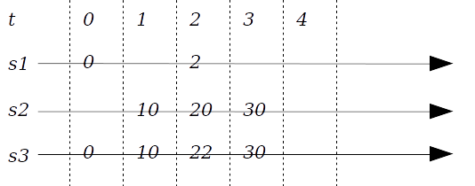
Figure E.4 Merge test
Filter
Filter :: (a → Bool) → Stream a → Stream a
Filter events by a predicate:
occs (Filter pred s) = filter (\(t, a) → pred a) (occs s)
Test cases
See figure E.5.
let s1 = MkStream [([0], 5), ([1], 6), ([2], 7)]
let s2 = Filter odd s1
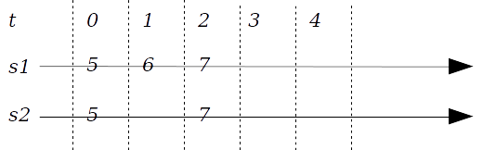
Figure E.5 Filter test
SwitchS
SwitchS :: Cell (Stream a) → Stream a
Act like the stream that is the current value of the cell:
occs (SwitchS c) = scan Nothing a sts
where (a, sts) = steps c
scan mt0 a0 ((t1, a1):as) =
filter (\(t, a) → maybe True (t >) mt0 && t <= t1) (occs a0)
++ scan (Just t1) a1 as
scan mt0 a0 [] =
filter (\(t, a) → maybe True (t >) mt0) (occs a0)
Test cases
See figure E.6.
let s1 = MkStream [([0], 'a'), ([1], 'b'), ([2], 'c'), ([3], 'd')]
let s2 = MkStream [([0], 'W'), ([1], 'X'), ([2], 'Y'), ([3], 'Z')]
let c = Hold s1 (MkStream [([1], s2)]) [0]
let s3 = SwitchS c
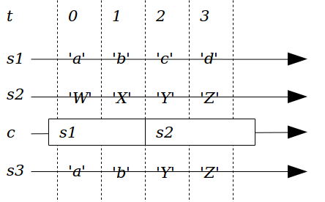
Figure E.6 SwitchS test
Execute
Execute :: Stream (Reactive a) → Stream a
Unwrap the Reactive helper monad value of the occurrences, passing it the time of the occurrence. This is commonly used when we want to construct new logic to activate with SwitchC or SwitchS:
occs (Execute s) = map (\(t, ma) → (t, run ma t)) (occs s)
Test cases
See figure E.7.
let s1 = MkStream [([0], return 'a')]
let s2 = Execute s1
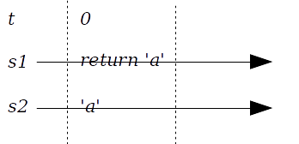
Figure E.7 Execute test
Updates
Updates :: Cell a → Stream a
A stream representing the steps in a cell, which breaks the principle of non-detectability of cell steps. Updates must therefore be treated as operational primitives, for use only in defining functions that don’t expose cell steps to the caller. If the cell had been the Hold of stream s, it would be equivalent to Coalesce (flip const) s.
occs (Updates c) = sts
where (_, sts) = steps c
Test cases
See figure E.8.
let c = Hold 'a' (MkStream [([1], 'b'), ([3], 'c')]) [0]
let s = Updates c
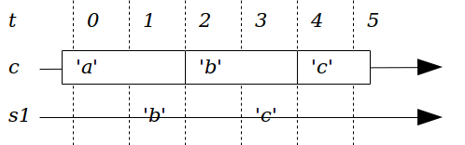
Figure E.8 Updates test
Value
Value :: Cell a → T → Stream a
Like Updates, except it also fires once with the current cell value at the time t0 when it’s constructed. Also like Updates, Value breaks the non-detectability of cell steps and so is treated as an operational primitive:
occs (Value c t0) = coalesce (flip const) ((t0, a) : sts)
where (a, sts) = chopFront (steps c) t0
chopFront :: C a → T → C a
chopFront (i, sts) t0 = (at (i, sts) t0, filter (\(t, a) → t >= t0) sts)
Note that Value has the property that it can create an event occurrence out of nothing. It’s possible to argue that it’s reconstructing an event occurrence that we can prove exists—the one that drives the Execute that must have executed this instance of Value. It’s the same event occurrence that Sample implies the existence of if it’s seen as being based on Snapshot.
Test cases
See figure E.9
let c = Hold 'a' (MkStream [([1], 'b'), ([3], 'c')]) [0]
let s = Value c [0]

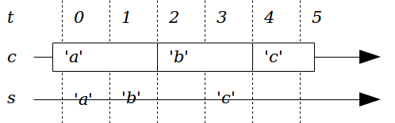
Figure E.9 Value test 1
See figure E.10
let c = Hold 'a' (MkStream [([0], 'b'), ([1], 'c'), ([3], 'd')]) [0]
let s = Value c [0]

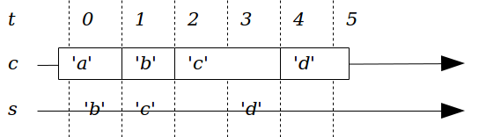
Figure E.10 Value test 2
Split
Split :: Stream [a] → Stream a
Put the values into newly created child time steps:
occs (Split s) = concatMap split (coalesce (++) (occs s))
where split (t, as) = zipWith (\n a → (t++[n], a)) [0..] as
Test cases
See figure E.11.
let s1 = MkStream [([0], ['a', 'b']), ([1],['c'])]
let s2 = Split s1
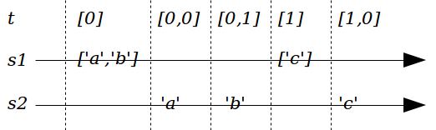
Figure E.11 Split test
Constant
Constant :: a → Cell a
A cell with an initial value but no steps:
steps (Constant a) = (a, [])
Note that Constant is non-primitive. It can be defined in terms of Hold and Never.
Test cases
See figure E.12.
let c = Constant 'a'
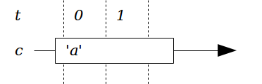
Figure E.12 Constant test
Hold
Hold :: a → Stream a → T → Cell a
A cell with an initial value of a and the specified steps, ignoring any steps before specified t0:
steps (Hold a s t0) = (a, coalesce (flip const)
(filter (\(t, a) → t >= t0) (occs s)))
We coalesce to maintain the invariant that step times in C a are increasing. Where input events are simultaneous, the last is taken. Events before t0 are discarded.
Test cases
See figure E.13.
let c = Hold 'a' (MkStream [([1], 'b'), ([3], 'c')]) [0]
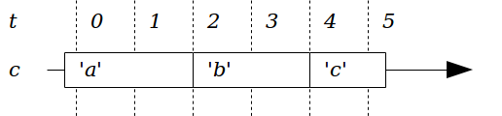
Figure E.13 Hold test
MapC
MapC :: (a → b) → Cell a → Cell b
Map a function over a cell:
steps (MapC f c) = (f a, map (\(t, a) → (t, f a)) sts)
where (a, sts) = steps c
Test cases
See figure E.14.
let c1 = Hold 0 (MkStream [([2], 3), ([3], 5)]) [0]
let c2 = MapC (1+) c1
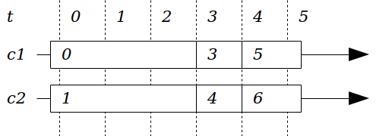
Figure E.14 MapC test
Apply
Apply :: Cell (a → b) → Cell a → Cell b
Applicative “apply” operation, as the basis for function lifting:
steps (Apply cf ca) = (f a, knit f fsts a asts)
where (f, fsts) = steps cf
(a, asts) = steps ca
knit _ ((tf, f):fs) a as@((ta, _):_)
| tf < ta = (tf, f a) : knit f fs a as
knit f fs@((tf, _):_) _ ((ta, a):as)
| tf > ta = (ta, f a) : knit f fs a as
knit _ ((tf, f):fs) _ ((ta, a):as)
| tf == ta = (tf, f a) : knit f fs a as
knit _ ((tf, f):fs) a [] = (tf, f a) : knit f fs a []
knit f [] _ ((ta, a):as) = (ta, f a) : knit f [] a as
knit _ [] _ [] = []
Note the “no glitch” rule: where both cells are updated in the same time t, we output only one output step.
Test cases
See figure E.15.
let cf = Hold (0+) (MkStream [([1], (5+)), ([3], (6+))]) [0]
let ca = Hold (100 :: Int) (MkStream [([1], 200), ([2], 300),
([4], 400)]) [0]
let cb = Apply cf ca
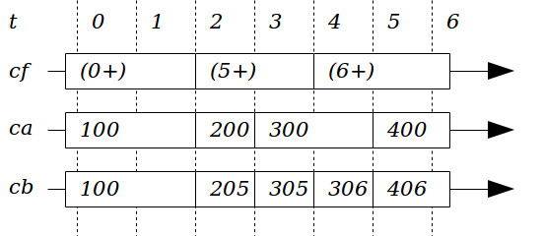
Figure E.15 Apply test
SwitchC
SwitchC :: Cell (Cell a) → T → Cell a
Act like the current cell that's contained in the cell:
steps (SwitchC c t0) = (at (steps (at (steps c) t0)) t0,
coalesce (flip const) (scan t0 a sts))
where (a, sts) = steps c
scan t0 a0 ((t1, a1):as) =
let (b, stsb) = normalize (chopBack
(chopFront (steps a0) t0) t1)
in ((t0, b) : stsb) ++ scan t1 a1 as
scan t0 a0 [] =
let (b, stsb) = normalize (chopFront (steps a0) t0)
in ((t0, b) : stsb)
normalize :: C a → C a
normalize (_, (t1, a) : as) | t1 == t0 = (a, as)
normalize as = as
chopBack :: C a → T → C a
chopBack (i, sts) tEnd = (i, filter (\(t, a) → t < tEnd) sts)
The purpose of normalize is to get rid of simultaneousness returned by chopFront where the first step occurs at the chop point t0. It discards the initial value and replaces that with the first step value. This is different than how Value uses chopFront: in that case, we keep the simultaneous events.
Test cases
See figure E.16.
let c1 = Hold 'a' (MkStream [([0], 'b'), ([1], 'c'),
([2], 'd'), ([3], 'e')]) [0]
let c2 = Hold 'V' (MkStream [([0], 'W'), ([1], 'X'),
([2], 'Y'), ([3], 'Z')]) [0]
let c3 = Hold c1 (MkStream [([1], c2)]) [0]
let c4 = SwitchC c3 [0]
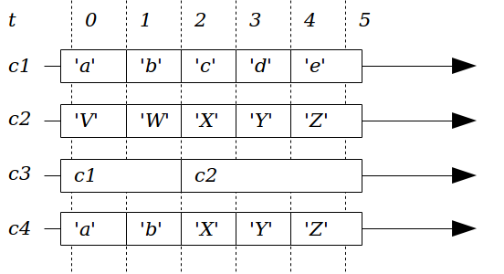
Figure E.16 SwitchC test 1
See figure E.17.
let c1 = Hold 'a' (MkStream [([0], 'b'), ([1], 'c'), ([2], 'd'),
([3], 'e')]) [0]
let c2 = Hold 'W' (MkStream [([1], 'X'), ([2], 'Y'), ([3], 'Z')]) [0]
let c3 = Hold c1 (MkStream [([1], c2)]) [0]
let c4 = SwitchC c3 [0]
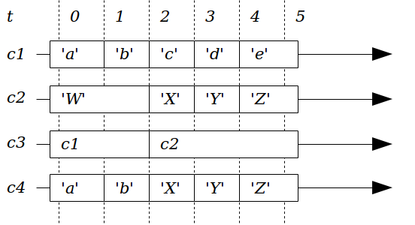
Figure E.17 SwitchC test 2
See figure E.18.
let c1 = Hold 'a' (MkStream [([0], 'b'), ([1], 'c'),
([2], 'd'), ([3], 'e')]) [0]
let c2 = Hold 'X' (MkStream [([2], 'Y'), ([3], 'Z')]) [0]
let c3 = Hold c1 (MkStream [([1], c2)]) [0]
let c4 = SwitchC c3 [0]
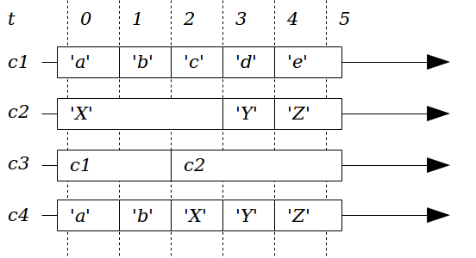
Figure E.18 SwitchC test 3
See figure E.19.
let c1 = Hold 'a' (MkStream [([0], 'b'), ([1], 'c'),
([2], 'd'), ([3], 'e')]) [0]
let c2 = Hold 'V' (MkStream [([0], 'W'), ([1], 'X'),
([2], 'Y'), ([3], 'Z')]) [0]
let c3 = Hold '1' (MkStream [([0], '2'), ([1], '3'),
([2], '4'), ([3], '5')]) [0]
let c4 = Hold c1 (MkStream [([1], c2), ([3], c3)]) [0]
let c5 = SwitchC c4 [0]
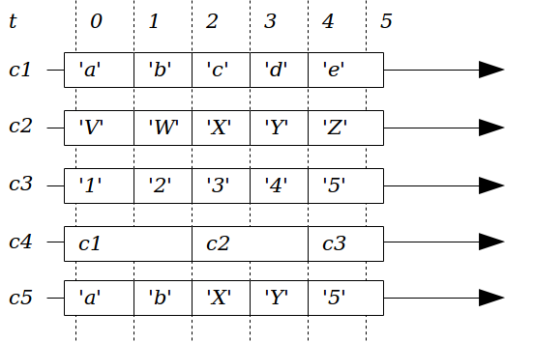
Figure E.19 SwitchC test 4
Sample
Sample :: Cell a → T → a
Extract the observable value of the cell at time t:
sample :: Cell a → Reactive a
sample c = Reactive (at (steps c))
Test cases
See figure E.20.
let c = Hold 'a' (MkStream [([1], 'b')]) [0]
let a1 = run (sample c) [1]
let a2 = run (sample c) [2]
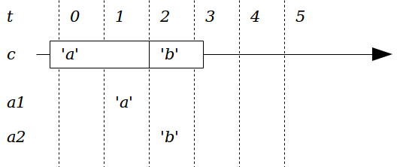
Figure E.20 Sample test

